Chateau on the Park, Christchurch
Abacus Chateau Pty Limited ACN116 807 919
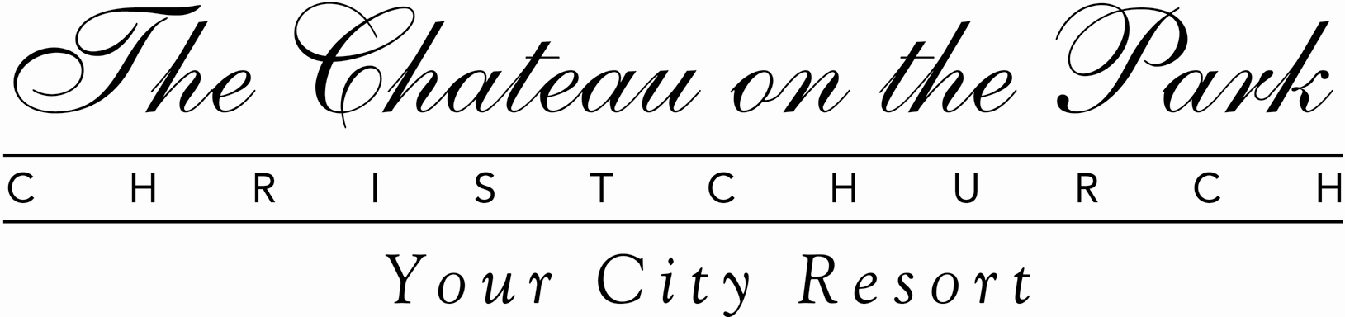

RESERVATION REQUEST FORM for ATNAC 2013 & 22 ITC SS EEGN

Please send this form directly to the Chateau on the Park in order to secure your accommodation during ATNAC 2013 and 22 ITC SS EEGN, to be held in Christchurch between the 20th and the 22nd of Nov 2013. Reference C*UNI1911

NAME:

ADDRESS:

TELEPHONE: ___________________________ CELL: _________________________________

ARRIVAL DATE: _____________________E.T.A.__________DEPARTURE DATE:___________

NO OF GUESTS OCCUPYING ROOM :_________________________

SPECIAL REQUIREMENTS: __________________________________

ACCOMMODATION: DOUBLE TWIN SHARE SINGLE

PLEASE GUARANTEE MY BOOKING WITH THE CREDIT CARD NUMBER LISTED BELOW:

CARD TYPE: AMEX DINERS MASTERCARD VISA JCB

CARD NUMBER:____________________________________ EXPIRY DATE:____________________

SIGNATURE:___________________________________________________________________________
NB: We note that all charges will be settled on checkout.

CONFERENCE ACCOMMODATION INFORMATION:
Check-in time at the Hotel is 1:00pm and check-out time is 10:30am. We are unable to guarantee access to guest rooms outside these times, however we will endeavour to meet any early check-in and late check-out requests as required. (Please note that there may be a late departure fee for check-outs after 10:30am).
In the event that you no longer require your accommodation, please contact the Hotel immediately to avoid any possible cancellation fees. In the case of “no show” on the arrival date given above, one night’s accommodation will be payable as a no-show fee and the whole booking will be automatically cancelled. Any further accommodation requirements will be on a space availability basis only.
This form is to be returned to the Hotel no later than on 11 October 2013 to qualify for the special room rate of $195.50 inclusive of GST per single/twin/double room per night, unless all rooms reserved for this special rate are booked earlier.

The Chateau On The Park, P.O.Box 8161, Riccarton, Christchurch

Fax: + 64 3 348-8990 E-mail: res@chateau-park.co.nz

